48 | Soft Tissue Neck | 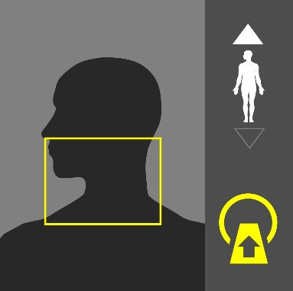
Purpose:
Evaluation of Tumors, infections, inflammation, neurogenic , congenital and traumatic conditions of head and neck ( paraspinal, larynx , oral cavity nasopharynx, pharynx, salivary glands and cervical lymph nodes , neck muscles and carotid sheaths)
Instructions:
Use the image on the right as a guide.
Dual Scanograms |  | 120kVp | 20mA

Patient Preparation
- Contrast media preparation is required.
- 22G -24G cannula is required.

Scan Details
Mode | Beam | Pitch | kVp | mA | Sure Exp. 3D | FOV
GG-Helical | 0.5 x 80 | HP Detail | 120 | R*** | Quality | M

Procedure & Reconstruction Details
Phase | Coverage | Timing | Reconstructions (mm)
Plain | Soft palate to aortic arch | - | Ax. 2X2  Cor.  Sag.
 | Volume: 50-75cc Rate: 2.0-3.0cc/s Delay: 45s
Neck +C | Soft palate to aortic arch |  | Ax. 2X2  Cor. 3x3  Sag. 3x3

Algorithm Details
Neck | Kernel | FC08 | Filter | AIDR 3D STND | Boost | OFF | OSR | On

Comments

49 | Cervical Spine | 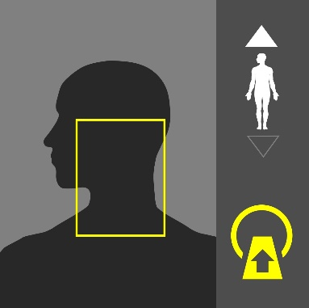
Purpose:
Evaluation of paraspinal tumors/ Infections and trauma and surgical planning of the Cervical Spine.
Instructions:
Use the image on the right as a guide.
Dual Scanograms |  | 120kVp | 20mA

Patient Preparation
No preparation is required

Scan Details
Mode | Beam | Pitch | kVp | mA | Sure Exp. 3D | FOV
W-Volume | 0.5 x 80 | - | 120 | 280 | OFF | M

Procedure & Reconstruction Details
Phase | Coverage | Timing | Reconstructions (mm)
C-Spine | Cranio-vertebral Junction to T1 | - | Ax. 1x1 (Spine)(Soft)  Cor. 3x3 (Spine)  Sag. 3x3 (Spine)(Soft)

Algorithm Details
Spine | Kernel | FC35 | Filter | AIDR 3D STND | Boost | OFF | OSR | On
Soft |  | FC09 |  | AIDR 3D STND |  | OFF |  | On

Comments
- Use “SEMAR” version of the protocol when metallic implants are present.
- VR and 3D post-processing for all implants is required.

51 | Carotid CTA (SureSubtraction) | 
Purpose:
Examining of pathologies of the carotid artery and branches and that tumors of carotid sheath.
Instructions:
Use the image on the right as a guide.
Dual Scanograms |  | 120kVp | 20mA

Patient Preparation
- Contrast media preparation is required.
- 18-20G cannula is required.

Scan Details
Mode | Beam | Pitch | kVp | mA | Sure Exp. 3D | FOV
Helical | 0.5 x 80 | HP STND | 100 | R*** | Low Dose | M
Helical | 0.5 x 80 | HP STND | 100 | R*** | Quality | M

Procedure & Reconstruction Details
Phase | Coverage | Timing | Reconstructions (mm)
Plain | Mid forehead to below origins of arch vessels | - | Ax. 2X2  Cor. 2x2  Sag.
 | Volume: 50cc Rate: 4-5.0cc/s Delay: SureStart
Carotid CTA | Mid forehead to below origins of arch vessels | Sure  Start | Ax. 1x1  Cor. 2x2, 5x1 MIP  Sag. 2x2, 5x1 MIP

Algorithm Details
Carotid CTA | Kernel | FC43 | Filter | AIDR 3D STND | Boost | OFF | OSR | On

Comments
- MIP and curved vessel view required.

52 | Neck/Chest/Abdomen/Pelvis Non-Staging (-C/+C) | 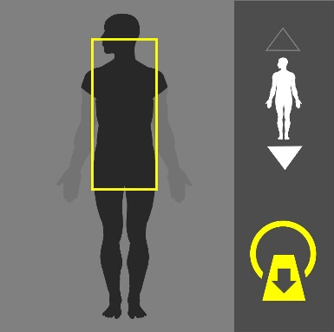
Purpose:
Screening abscess, infection spread and polytrauma.

Instructions:
Use the image on the right as a guide. Cover the entire area from the neck to the pelvis as shown.
Dual Scanograms |  | 120kVp | 50mA

Patient Preparation
- Contrast media preparation is required. 22G -24G cannula is required.
- Give 1.5L water over 90 minutes in equally spaced doses. Give 300-500 ml water on table stat.
- If it is acute emergency and there is no time- water contrast may be skipped- proceed directly to scanning.
- Discuss with radiologist, if he prefers positive contrast then use same dose regime but with oral iodine based contrast instead of water.

Scan Details
Mode | Beam | Pitch | kVp | mA | Sure Exp. 3D | FOV
Helical | 0.5 x 80 | HP Fast | 120 | R*** | Quality | L

Procedure & Reconstruction Details
Phase | Coverage | Timing | Reconstructions (mm)
Plain | Soft palate to below ischium | - | Ax. 2x2 (abdomen)(lung)  Cor.  Sag.
 | Volume: 100-125cc Rate: 2.0-3.0cc/s Delay: 55s
Brain +C | Soft palate to below ischium | 60s | Ax. 2x2 (abdomen)  Cor. 3x3 (abdomen)  Sag. 3x3 (abdomen)

Algorithm Details
Abdomen | Kernel | FC08 | Filter | AIDR 3D STND | Boost | OFF | OSR | On
Lung |  | FC52 |  | OFF |  | OFF |  | On

Comments

53 | Neck/Chest/Abdomen/Pelvis Staging (2 Phases) | 
Purpose:
Screening metastasis spread, lymphoma.

Instructions:
Use the image on the right as a guide. Cover the entire area from the neck to the pelvis as shown.
Dual Scanograms |  | 120kVp | 50mA

Patient Preparation
- Contrast media preparation is required. 22G -24G cannula is required.**
- Give 1.5L water over 90 minutes in equally spaced doses. Give 300-500 ml water on table stat.
- If it is acute emergency and there is not time- water contrast may be skipped- proceed directly to scanning. Discuss with radiologist, if he prefers positive contrast then use same dose regime but with oral iodine based contrast instead of water. Discuss need of contrast enema.

Scan Details
Mode | Beam | Pitch | kVp | mA | Sure Exp. 3D | FOV
Helical | 0.5 x 80 | HP Fast | 120 | R*** | Quality | L

Procedure & Reconstruction Details
Phase | Coverage | Timing | Reconstructions (mm)
Plain | Soft Palate to below ischium | - | Ax. 2x2 (abdomen)(lung)  Cor.  Sag.
 | Volume: 100-125cc Rate: 3.0-4.0cc/s Delay: See below
Late Arterial | Soft Palate to iliac crest | 35s | Ax. 2x2 (abdomen)  Cor.  Sag.
Portal Venous | Above diaghragm to below ischium | 60s | Ax. 2x2 (abdomen)  Cor. 3x3 (abdomen)  Sag. 3x3 (abdomen)

Algorithm Details
Abdomen | Kernel | FC08 | Filter | AIDR 3D STND | Boost | OFF | OSR | On
Lung |  | FC52 |  | OFF |  | OFF |  | On

Comments

